Beaker
# Source: AI Source: Provided by: [Data Path: Persons Table -> ID Column: 1, Name_En Column: Motasem Essam] -> From: [ChatGPT] on [7/17/2026]
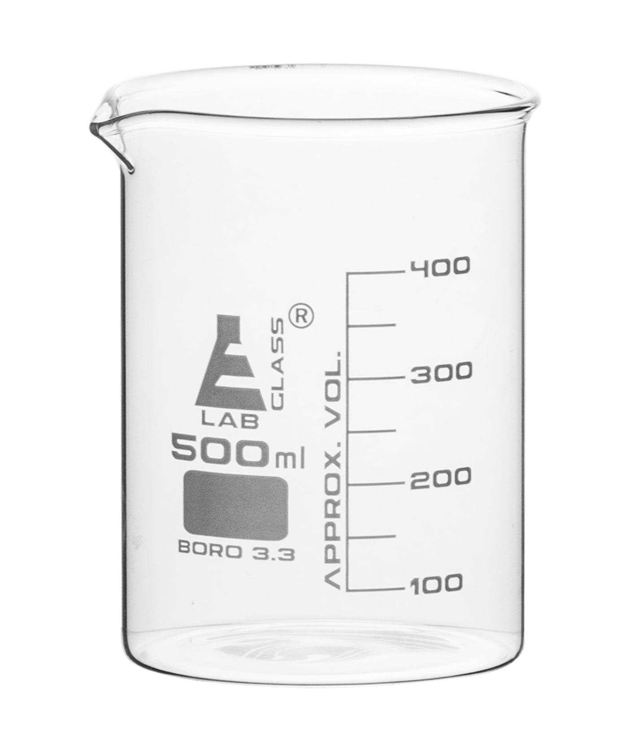
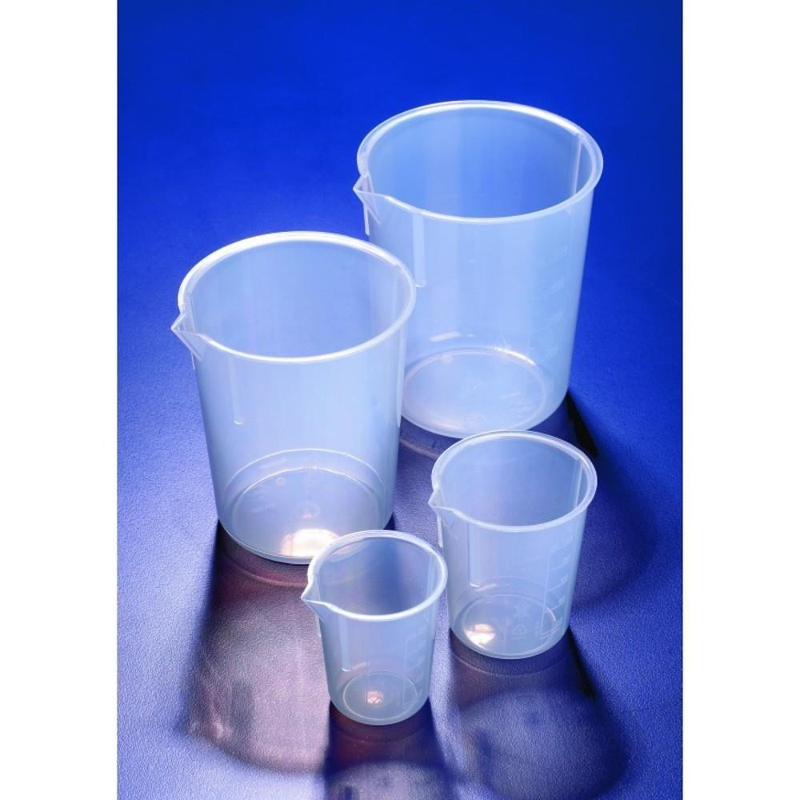
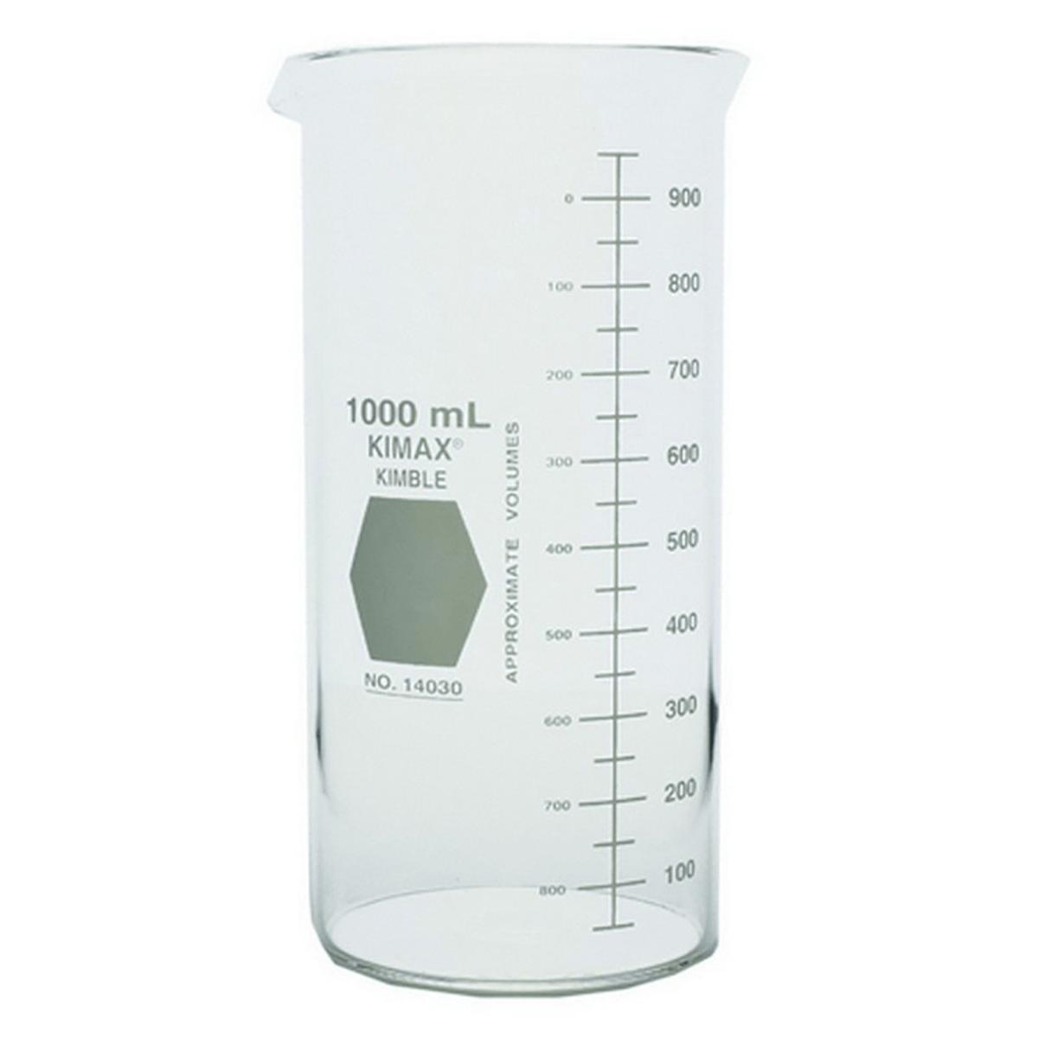
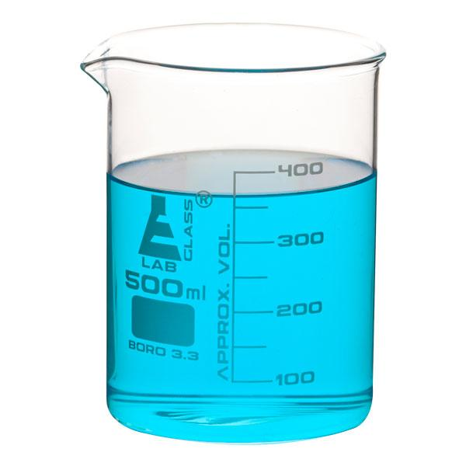
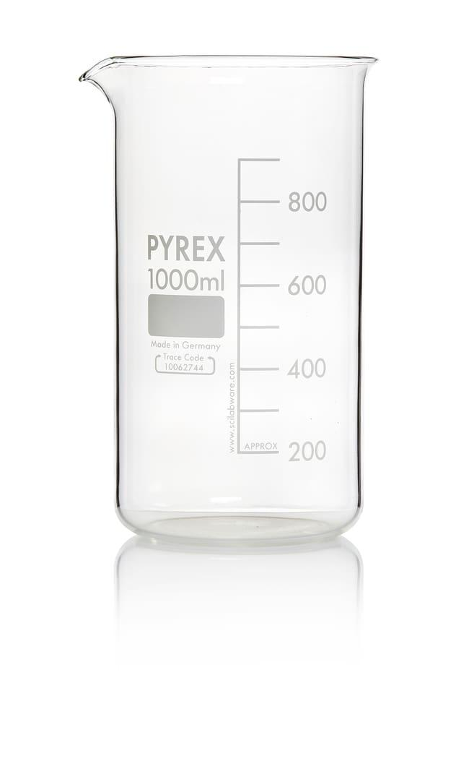
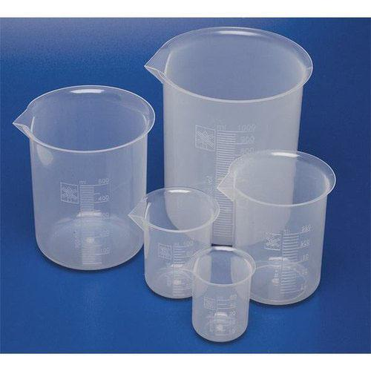
A Beaker is a general-purpose laboratory container used for holding, mixing, heating, and pouring liquids. Although most beakers have graduation marks, they provide approximate volume measurements and are not intended for high-precision volume measurement.
Beakers are among the most commonly used laboratory instruments in chemistry, biology, medicine, pharmaceuticals, education, food science, and industrial laboratories.

Definition
# Source: AI Source: Provided by: [Data Path: Persons Table -> ID Column: 1, Name_En Column: Motasem Essam] -> From: [ChatGPT] on [7/17/2026]
A Beaker is a cylindrical laboratory container with a flat bottom and pouring spout, designed for holding, mixing, heating, and transferring liquids, while providing approximate volume measurements.

Purpose
# Source: AI Source: Provided by: [Data Path: Persons Table -> ID Column: 1, Name_En Column: Motasem Essam] -> From: [ChatGPT] on [7/17/2026]
A beaker is used to:
- Hold liquids.
- Mix chemicals.
- Heat solutions.
- Dissolve solids.
- Pour liquids safely.
- Collect samples.
- Measure approximate volumes.

Principle of Operation
# Source: AI Source: Provided by: [Data Path: Persons Table -> ID Column: 1, Name_En Column: Motasem Essam] -> From: [ChatGPT] on [7/17/2026]
A beaker functions primarily as a container. Its graduation marks provide an approximate indication of volume, but because of their relatively wide spacing and manufacturing tolerances, they should not be used where precise measurements are required.

Main Components
# Source: AI Source: Provided by: [Data Path: Persons Table -> ID Column: 1, Name_En Column: Motasem Essam] -> From: [ChatGPT] on [7/17/2026]
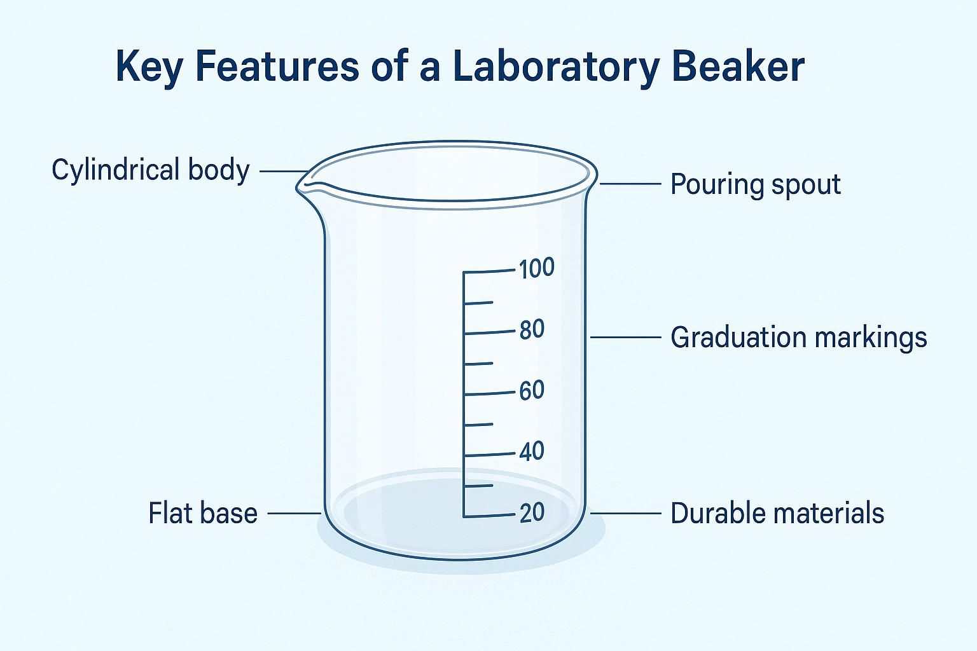
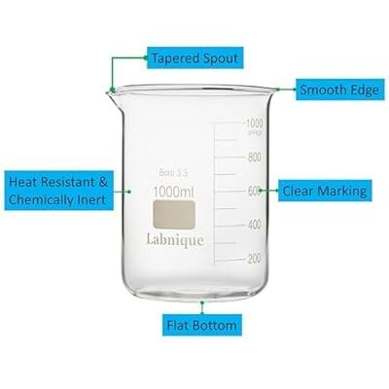
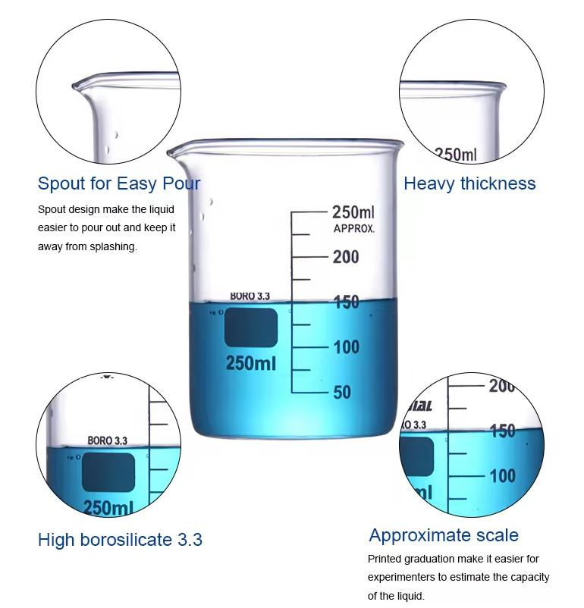
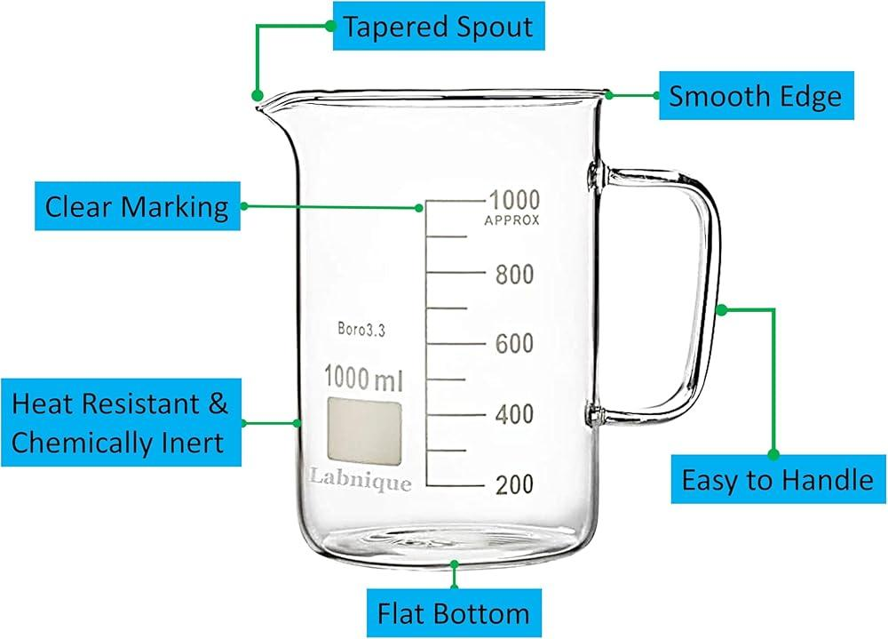
A typical beaker consists of:
- Cylindrical body
- Graduation marks
- Pouring spout
- Flat base
- Thick walls (glass or plastic)

Types of Beakers

1. Griffin Beaker (Low Form)
# Source: AI Source: Provided by: [Data Path: Persons Table -> ID Column: 1, Name_En Column: Motasem Essam] -> From: [ChatGPT] on [7/17/2026]
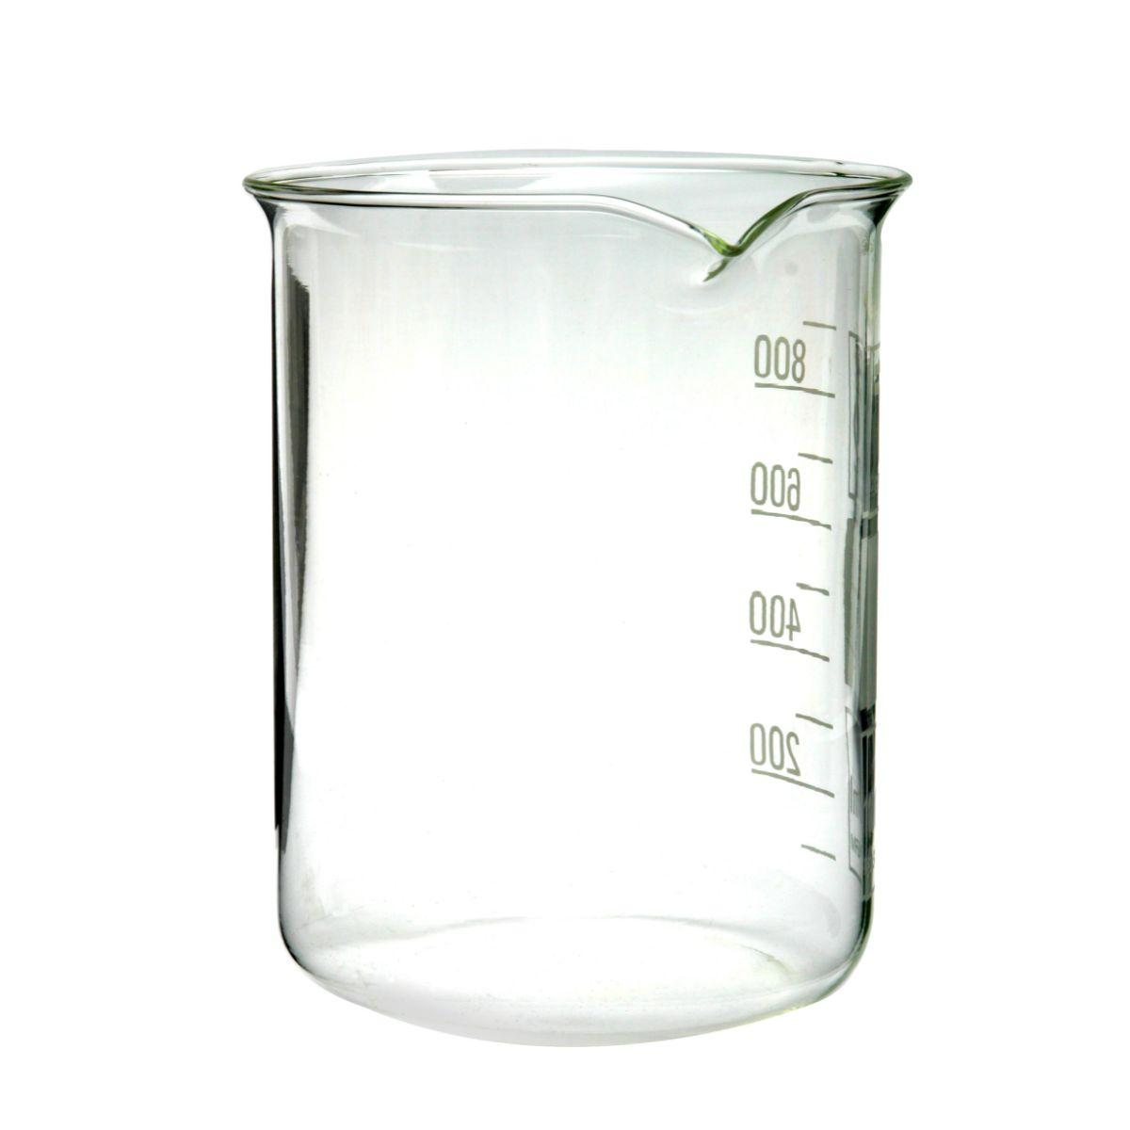
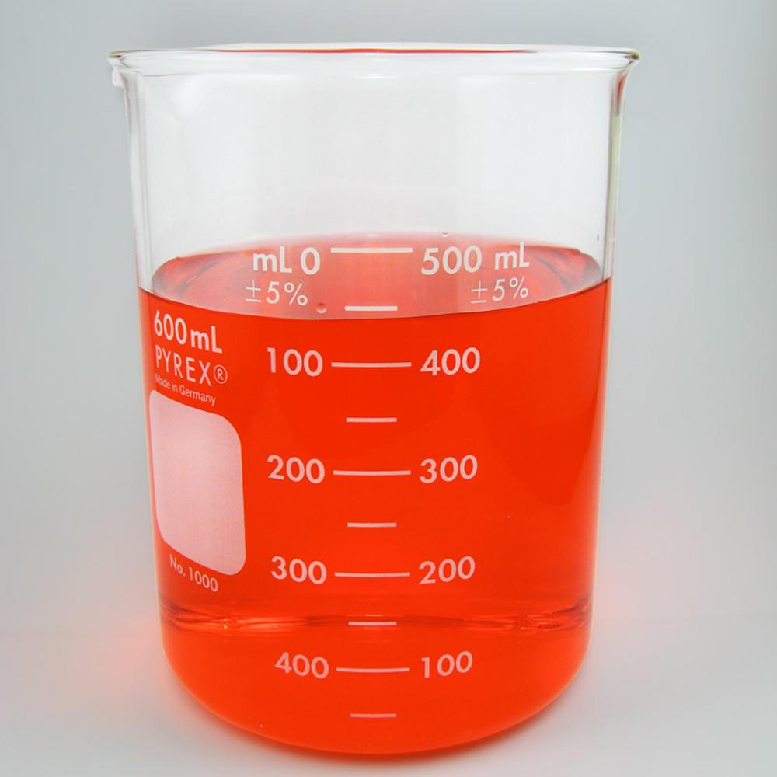
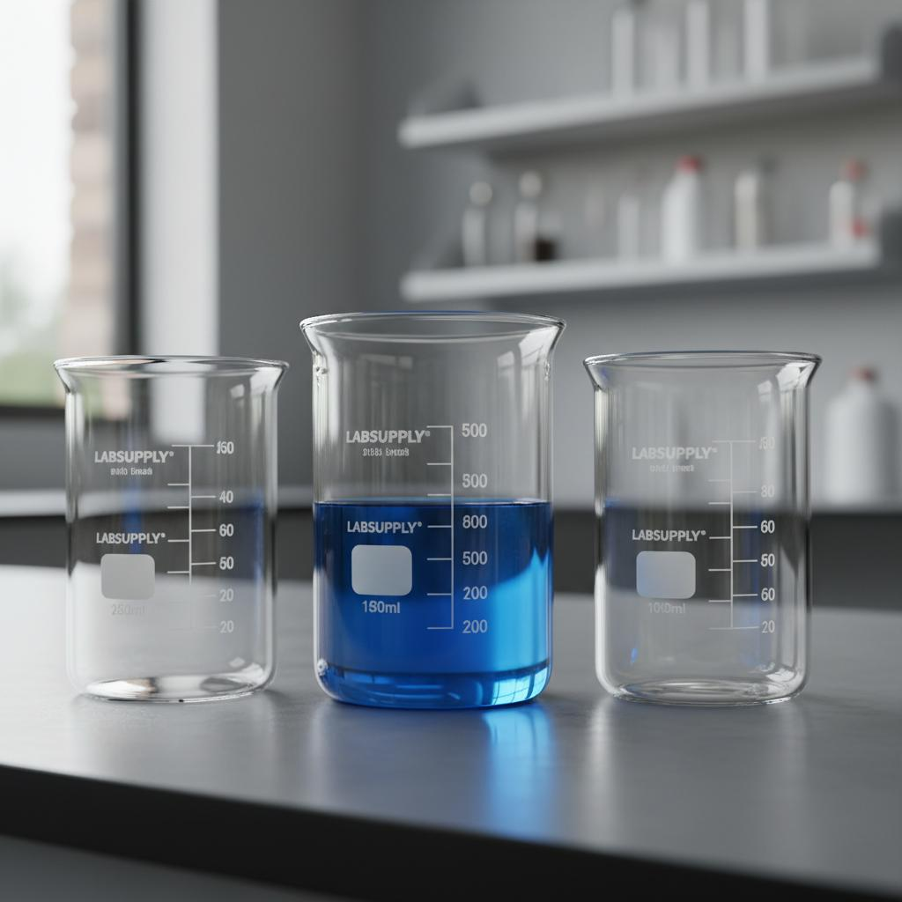
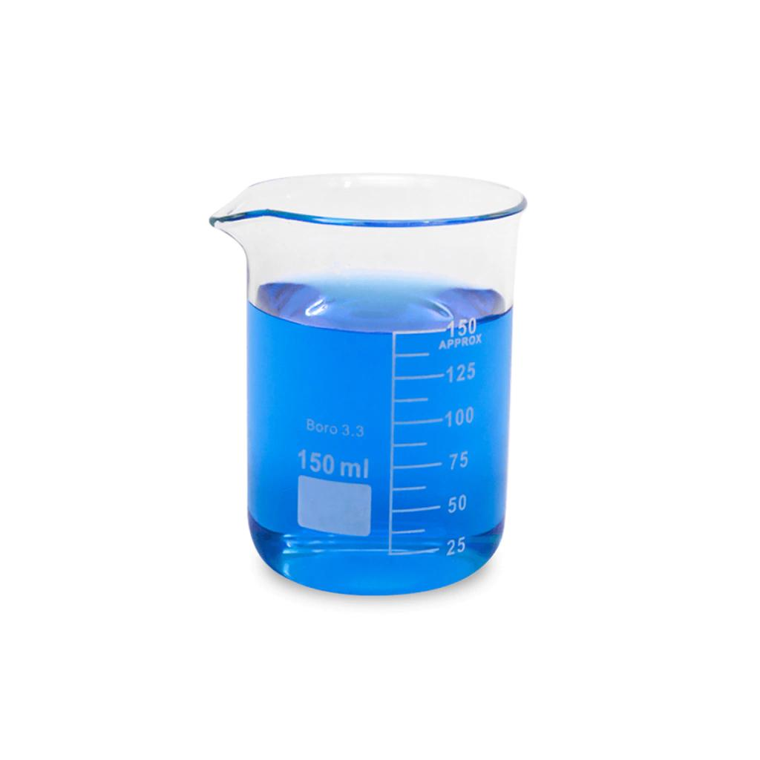
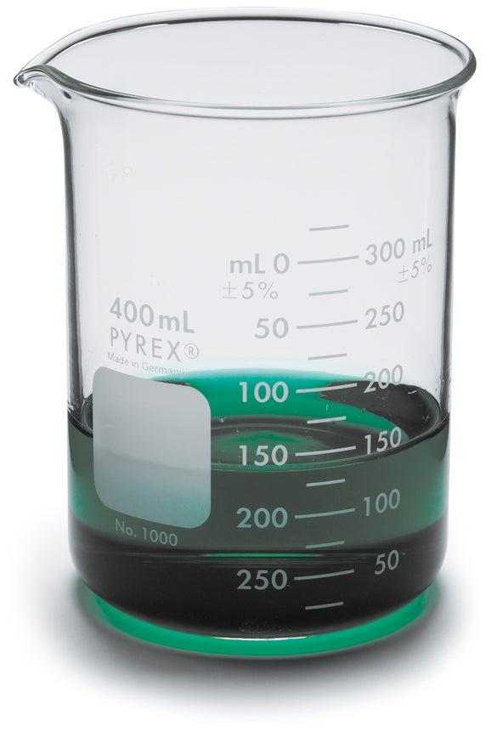
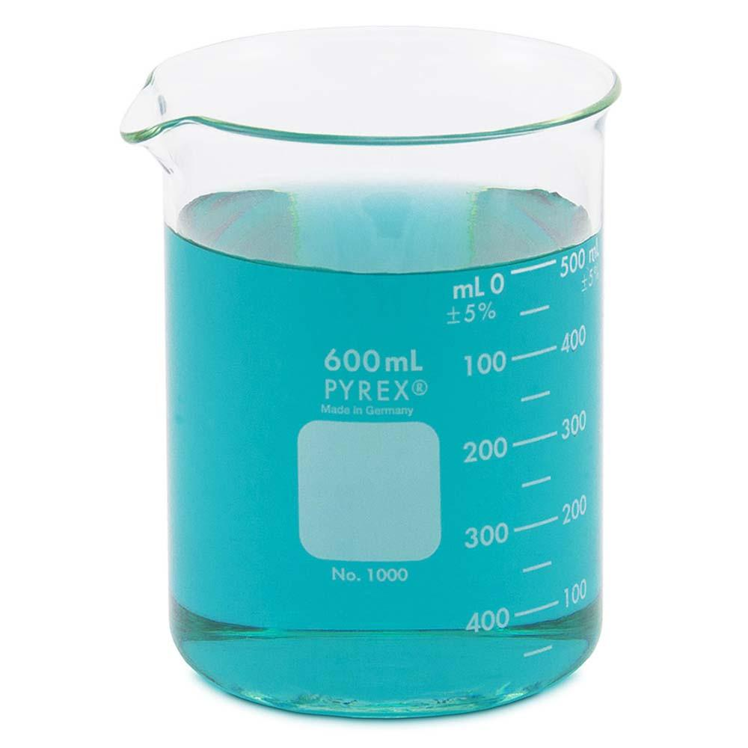
Description
The most common laboratory beaker, wider than it is tall.
Features
- Easy stirring
- Stable
- Widely used
Applications
- General laboratory work
- Mixing
- Heating

2. Berzelius Beaker (Tall Form)
# Source: AI Source: Provided by: [Data Path: Persons Table -> ID Column: 1, Name_En Column: Motasem Essam] -> From: [ChatGPT] on [7/17/2026]


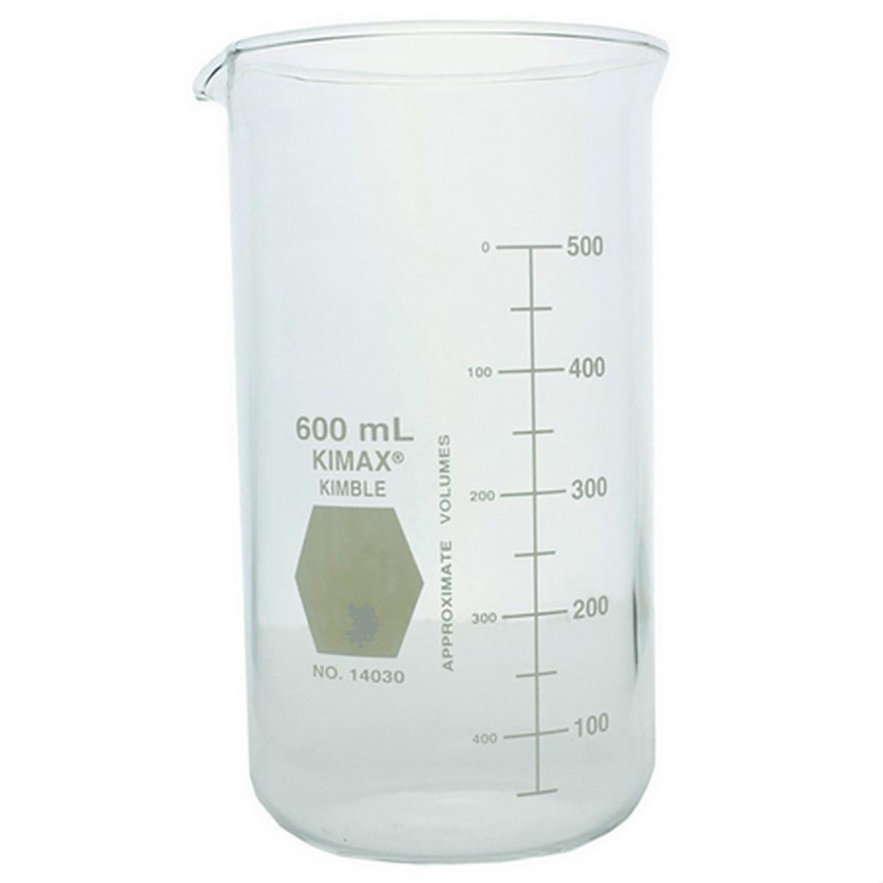
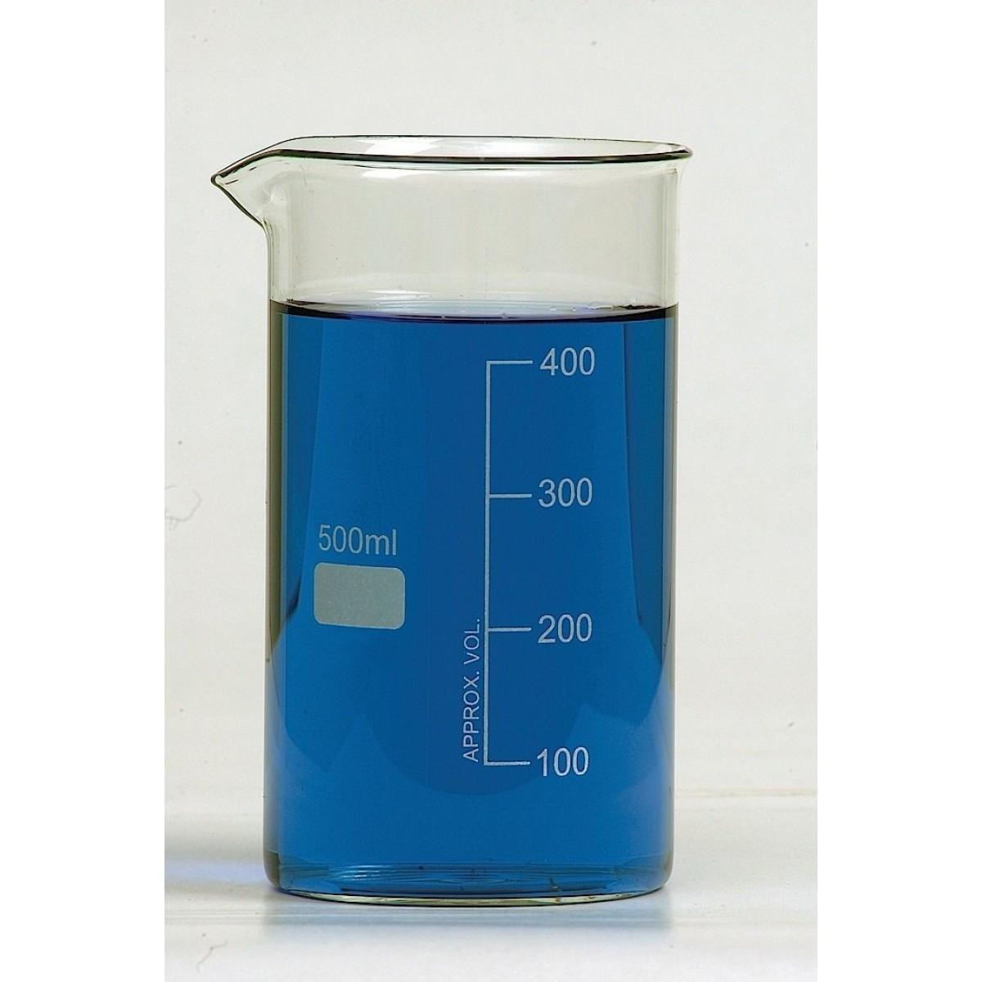
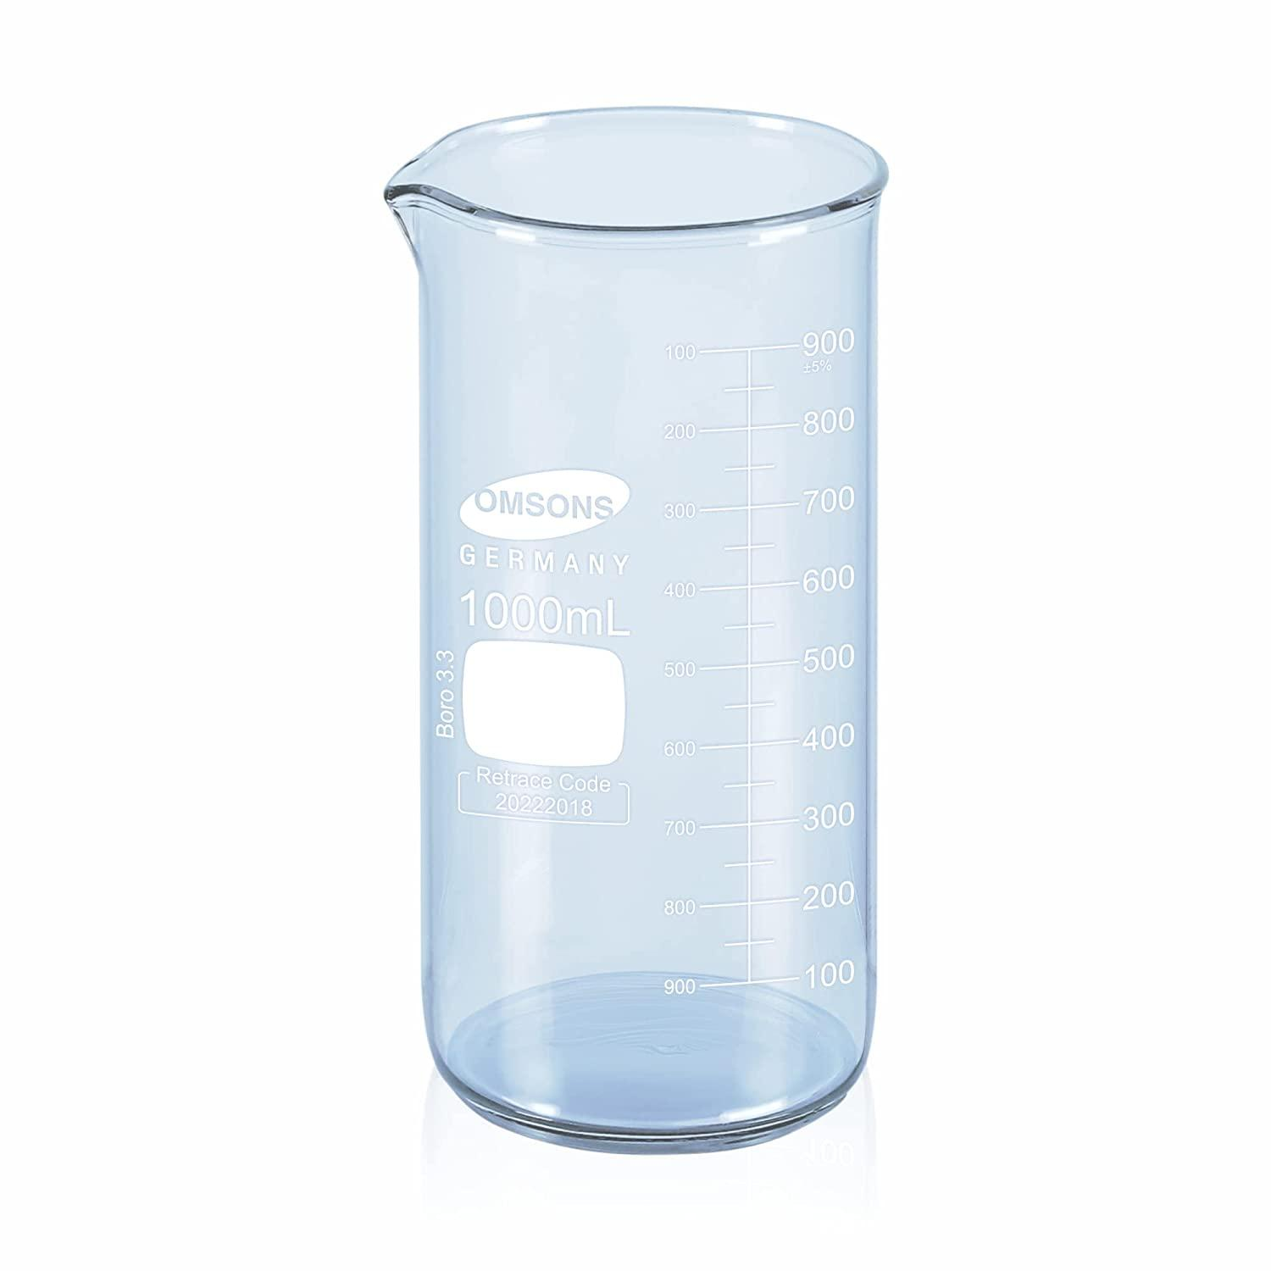
Description
Taller and narrower than the Griffin beaker.
Features
- Reduces splashing
- Suitable for taller liquid columns
Applications
- Specialized laboratory procedures
- Heating
- Mixing

3. Glass Beaker
# Source: AI Source: Provided by: [Data Path: Persons Table -> ID Column: 1, Name_En Column: Motasem Essam] -> From: [ChatGPT] on [7/17/2026]


Description
Usually made from borosilicate glass.
Features
- Heat resistant
- Chemically resistant
- Transparent
Applications
- Chemistry
- Biology
- Pharmaceutical laboratories

4. Plastic Beaker
# Source: AI Source: Provided by: [Data Path: Persons Table -> ID Column: 1, Name_En Column: Motasem Essam] -> From: [ChatGPT] on [7/17/2026]


Description
Manufactured from polypropylene or polyethylene.
Features
- Lightweight
- Break resistant
- Resistant to many chemicals
Applications
- Schools
- Field laboratories
- General laboratory use

Common Materials
# Source: AI Source: Provided by: [Data Path: Persons Table -> ID Column: 1, Name_En Column: Motasem Essam] -> From: [ChatGPT] on [7/17/2026]
Beakers are commonly made from:
- Borosilicate glass
- Polypropylene (PP)
- Polyethylene (PE)
- PTFE (specialized chemical applications)

Common Capacities
# Source: AI Source: Provided by: [Data Path: Persons Table -> ID Column: 1, Name_En Column: Motasem Essam] -> From: [ChatGPT] on [7/17/2026]
Typical capacities include:
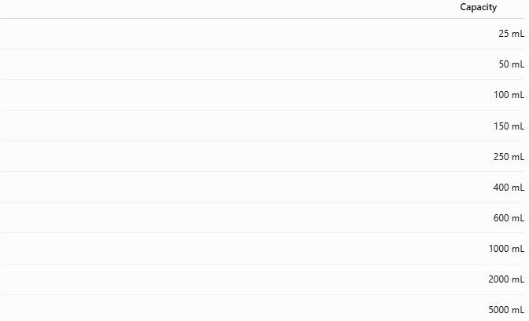
Capacity
25 mL
50 mL
100 mL
150 mL
250 mL
400 mL
600 mL
1000 mL
2000 mL
5000 mL

Measuring Units
# Source: AI Source: Provided by: [Data Path: Persons Table -> ID Column: 1, Name_En Column: Motasem Essam] -> From: [ChatGPT] on [7/17/2026]
Beakers usually display:
- Milliliters (mL)
- Liters (L)

Resolution
# Source: AI Source: Provided by: [Data Path: Persons Table -> ID Column: 1, Name_En Column: Motasem Essam] -> From: [ChatGPT] on [7/17/2026]
Typical graduation intervals:
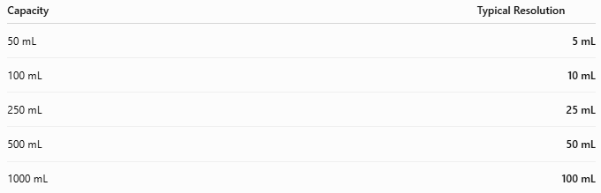
Capacity | Typical Resolution
50 mL | 5 mL
100 mL | 10 mL
250 mL | 25 mL
500 mL | 50 mL
1000 mL | 100 mL

Measuring Range
# Source: AI Source: Provided by: [Data Path: Persons Table -> ID Column: 1, Name_En Column: Motasem Essam] -> From: [ChatGPT] on [7/17/2026]
Typical measuring range:
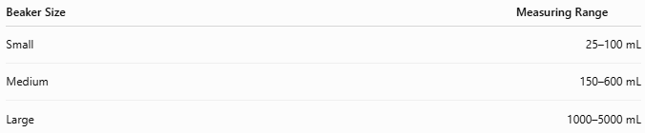
Beaker Size | Measuring Range
Small | 25–100 mL
Medium | 150–600 mL
Large | 1000–5000 mL

How to Use a Beaker
# Source: AI Source: Provided by: [Data Path: Persons Table -> ID Column: 1, Name_En Column: Motasem Essam] -> From: [ChatGPT] on [7/17/2026]
- Place the beaker on a flat surface.
- Add the required liquid or solid.
- Use the graduation marks only for approximate volume estimates.
- Stir if necessary.
- Heat on a hot plate or with appropriate laboratory equipment if required.
- Pour using the spout.

Example
# Source: AI Source: Provided by: [Data Path: Persons Table -> ID Column: 1, Name_En Column: Motasem Essam] -> From: [ChatGPT] on [7/17/2026]
A beaker is filled to the graduation marked:
250 mL
Actual volume is approximately 250 mL, but the exact volume may differ slightly depending on the beaker's tolerance.

Accuracy
# Source: AI Source: Provided by: [Data Path: Persons Table -> ID Column: 1, Name_En Column: Motasem Essam] -> From: [ChatGPT] on [7/17/2026]
Beakers are not precision measuring instruments.
Typical accuracy:
Instrument | Accuracy
Beaker | Approximately ±5% (varies by size and manufacturer)
Graduation marks are intended for estimation rather than precise measurement.

Sources of Error
# Source: AI Source: Provided by: [Data Path: Persons Table -> ID Column: 1, Name_En Column: Motasem Essam] -> From: [ChatGPT] on [7/17/2026]
Instrument Errors
- Manufacturing tolerances
- Worn or faded graduations
- Damaged rim or body

User Errors
- Reading from an incorrect angle (parallax)
- Assuming the graduations are precise
- Using the beaker instead of a graduated cylinder or volumetric flask for accurate measurements

Environmental Errors
- Temperature changes affecting liquid volume
- Evaporation
- Contamination from residues

Applications
# Source: AI Source: Provided by: [Data Path: Persons Table -> ID Column: 1, Name_En Column: Motasem Essam] -> From: [ChatGPT] on [7/17/2026]
Beakers are used in:
- Chemistry laboratories
- Biology laboratories
- Medical laboratories
- Pharmaceutical laboratories
- Schools and universities
- Food science
- Industrial quality control
- Chemical preparation
- Sample collection

Advantages
# Source: AI Source: Provided by: [Data Path: Persons Table -> ID Column: 1, Name_En Column: Motasem Essam] -> From: [ChatGPT] on [7/17/2026]
A beaker:
- Is versatile.
- Can be heated directly (glass models designed for heating).
- Is easy to pour because of its spout.
- Is available in many sizes.
- Is suitable for mixing and dissolving substances.

Limitations
# Source: AI Source: Provided by: [Data Path: Persons Table -> ID Column: 1, Name_En Column: Motasem Essam] -> From: [ChatGPT] on [7/17/2026]
A beaker:
- Provides only approximate volume measurements.
- Is less accurate than graduated cylinders, pipettes, or volumetric flasks.
- Glass beakers are fragile.
- Plastic beakers may not tolerate high temperatures.

Comparison with Other Volume Measuring Instruments
# Source: AI Source: Provided by: [Data Path: Persons Table -> ID Column: 1, Name_En Column: Motasem Essam] -> From: [ChatGPT] on [7/17/2026]
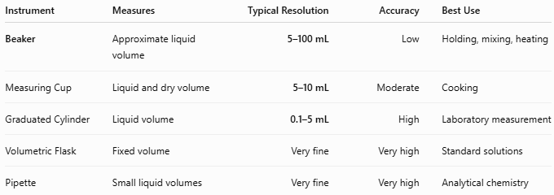
Instrument | Measures | Typical Resolution | Accuracy | Best Use
Beaker | Approximate liquid volume | 5–100 mL | Low | Holding, mixing, heating
Measuring Cup | Liquid and dry volume | 5–10 mL | Moderate | Cooking
Graduated Cylinder | Liquid volume | 0.1–5 mL | High | Laboratory measurement
Volumetric Flask | Fixed volume | Very fine | Very high | Standard solutions
Pipette | Small liquid volumes | Very fine | Very high | Analytical chemistry

Care and Maintenance
# Source: AI Source: Provided by: [Data Path: Persons Table -> ID Column: 1, Name_En Column: Motasem Essam] -> From: [ChatGPT] on [7/17/2026]
To maintain the beaker:
- Wash immediately after use.
- Avoid scratching graduation marks.
- Inspect glass for cracks before heating.
- Store carefully to prevent breakage.
- Use compatible cleaning agents.

Common Mistakes
# Source: AI Source: Provided by: [Data Path: Persons Table -> ID Column: 1, Name_En Column: Motasem Essam] -> From: [ChatGPT] on [7/17/2026]
- Using a beaker for precise measurements.
- Heating cracked glassware.
- Reading graduations as exact values.
- Pouring too quickly and causing spills.
- Using incompatible chemicals with plastic beakers.

Key Points
# Source: AI Source: Provided by: [Data Path: Persons Table -> ID Column: 1, Name_En Column: Motasem Essam] -> From: [ChatGPT] on [7/17/2026]
- A Beaker is primarily a laboratory container, not a precision measuring instrument.
- Common types:
  - Griffin Beaker (Low Form)
  - Berzelius Beaker (Tall Form)
  - Glass Beaker
  - Plastic Beaker
- Common units:
  - mL
  - L
- Typical capacities:
  - 25 mL to 5000 mL
- Used extensively for holding, mixing, heating, and transferring liquids.

Conclusion
# Source: AI Source: Provided by: [Data Path: Persons Table -> ID Column: 1, Name_En Column: Motasem Essam] -> From: [ChatGPT] on [7/17/2026]
A Beaker is one of the most fundamental and versatile pieces of laboratory equipment. While its graduated markings allow approximate volume estimation, its primary purpose is to hold, mix, heat, and transfer liquids and solutions safely and conveniently. Available in both glass and plastic forms and in a wide range of capacities, beakers are indispensable in scientific laboratories, educational institutions, pharmaceutical production, and industrial processes. For accurate volume measurements, however, instruments such as graduated cylinders, pipettes, or volumetric flasks should be used instead.

